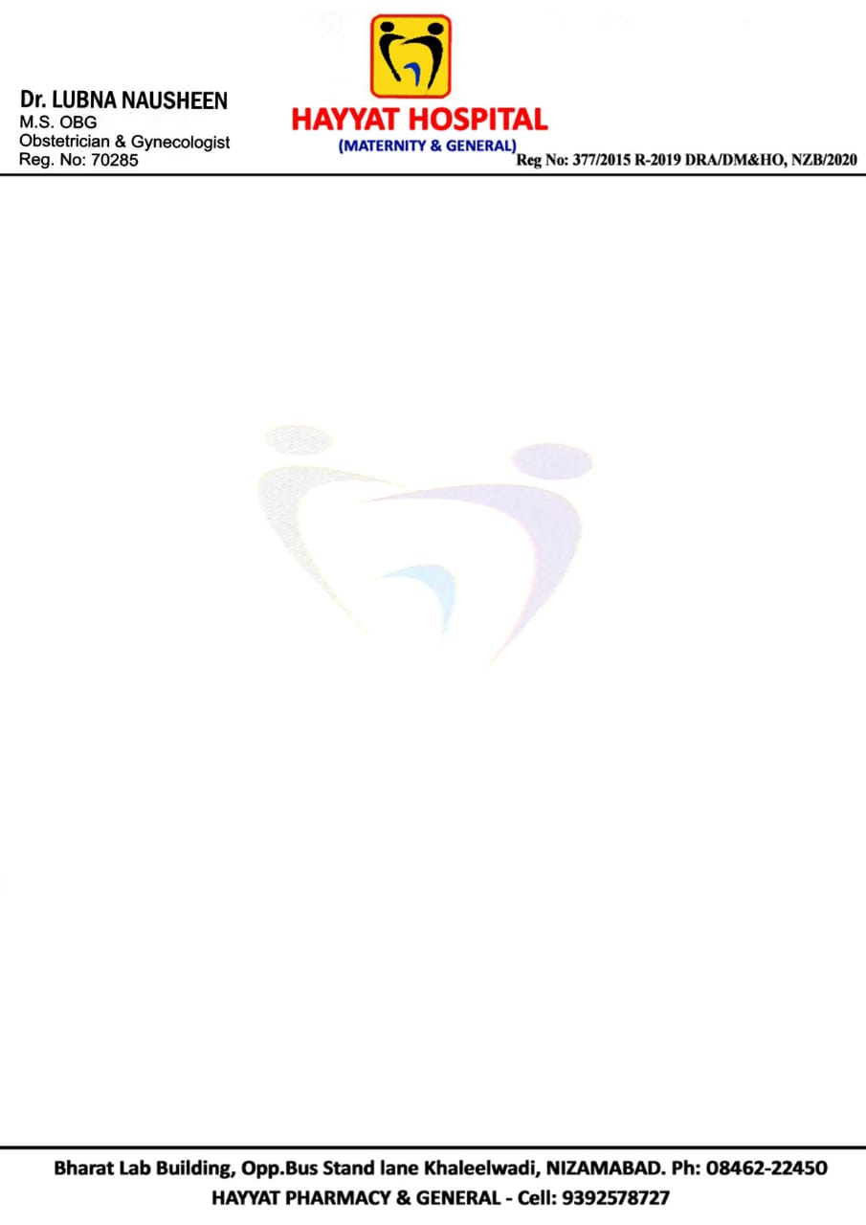

**Discharge Summary**

**Patient Details**

|  |  |  |  |
| --- | --- | --- | --- |
| Name | MRS. AFIFA SADAF | Age | 22 YRS |
| Admission No | MCIP210404163 | UMR No | MCU0022472 |
| Admission Dt. | 27-11-2022 | Gender | Female |
| Doctor Name | Dr. LUBNA NAUSHEEN M.S (OBG) | Mobile No | 7013230597 |
| Address | H.no 1-5-73, Phulong Street, Nizamabad  TELANGANA, INDIA | Blood Group | “O” Positive |
| Discharge Date | 30-11-2022 4:00 pm |  |  |

**Consultant**

|  |
| --- |
| Dr. LUBNA NAUSHEEN  M.S (OBG) Obstetrician & Gynecologist  Infertility Specialist |

**Diagnosis**

|  |
| --- |
| Co:Primi with 37 Week of gestation, breach position in Labour, premature rupture of membranes.  Emergency LSCS done with SA |

**Nature of Delivery / Operation**

|  |
| --- |
| Liquid less and single baby of approx. 2.75 kg @ 12:37 pm as breach with single loop of cord around the neck.  2 units of whole blood Transfusion done. |

**Personal History**

|  |
| --- |
| DIET – Normal  SLEEP – Normal  APPITIETE- Normal |

**Vitals**

|  |
| --- |
| H.B.% 8.4 gms/dL, BP(SIT-SUP-STND) / MMHG : 110/70, SPO2 L/MIN-RESP RETE/MIN : 99/85, PULSE/MIN-HEART RATE/BPM :117, TEMP: 98.9 (F) , BT: 1 min 50 Sec, CT: 4 min 00 sec |

**Treatment At Discharge**

|  |
| --- |
| Tab. Augmentin 625 – 5D (Twice a day)  Tab. Pantop 40 – 10D (Once a day)  Tab. Dolo 650 – 5D (Twice a day)  Tab. Limcee 500mg – 15D (Twice a day)  Tab. Livogen – 30D (Twice a day)  Tab. Calcimed – 30D (Once a day) |

**Review** – After 1 Month